Appendix 1: Detailed Evidence Summary Wye and Lugg SSSI
Natural England November 2022
This document summarises the key evidence used to undertake an interim assessment of the condition of some of the features on both the River Wye and River Lugg Sites of Special Scientific Interest (SSSIs). Further detailed information on the attributes/targets used is available in the Monitoring Specifications for the River Wye and River Lugg SSSIs. If you would like a copy of the Monitoring Specifications, please e-mail west.mindlands.enquiries@naturalengland.org.uk
Macrophytes, Diatoms and Macroinvertebrates
Macrophytes, Diatoms and Macroinvertebrates form a mandatory part of the condition assessment for the interest feature ‘rivers and streams’ (The River Wye is a H3260 Ranunculion type river).
The target status for macrophytes, diatoms and macroinvertebrates is High Ecological Status (HES).
All of WFD waterbodies within the Wye/Lugg SAC are classified as either moderate or good WFD status for macrophytes and phytopbenthos (combined) and therefore fail to meet the designated site target. Units 2 and 3 declined in status from Good to Moderate between 2014 and 2015. Units 4 saw a class improvement between 2016 and 2019 from moderate status to good. Units 5 and 6 have remained at moderate status since reporting in 2014.
Macroinvertebrates fail to meet the target in part or all of units 4, 5 and 6.
Table 1. Classification of macrophytes and macroinvertebrates as displayed on Catchment Data Explorer https://environment.data.gov.uk/catchment-planning/ManagementCatchment/3117
Unit |  | WFD WBID | Plant community | Macro-invertebrates
 |  |  | SAC/SSSI Target is HES | SAC/SSSI Target is HES
2 | Brockweir Bridge to Monmouth | GB109055037111 | Moderate*
3 | Monmouth to Ross | GB109055037111 | Moderate*
 |  | GB109055037112 | Good**
4 | Ross to Lugg Confluence | GB109055037112 | Good** | High
 | Lugg Confluence to Hereford | GB109055037112 | Good** | High
 |  | GB109055037113 | Moderate | Good*
5 | Hereford to Bredwardine Bridge | GB109055037113 | Moderate | Good*
6 | Bredwardine Bridge to Whitney Toll | GB109055037113 | Moderate | Good*
 |  | GB109055037116 | Unknown as NRW
7 | Whitney Toll to Hay | GB109055037116 | Unknown as NRW
1 | R Lugg (Wye SAC) Wye Confluence to Bodenham Weir | GB109055036790 | Moderate
 |  | GB109055042030 | Moderate
2 | Bodenham Weir to Leominster | GB109055042030 | Moderate
3 | Leominster to Mortimers Cross | GB109055042030 | Moderate
4 | Mortimers Cross to Presteigne | GB109055042030 | Moderate
* Indicates evidence that the
situation is declining
** Indicates evidence that the situation is improving

Atlantic salmon
Both rivers are deemed to be iconic for their salmon population. Salmon are a notified feature of the River Wye SSSI and SAC, and a feature component of clay river health in the Lugg. The salmon population of the River Wye is at a critical state, with the salmon run estimated at around 2000 to 3000 down from 50,000 a year, with angling catches down 94% from their peak in 1967 (River Wye Salmon Action Plan 2019).
Fundamental to the assessment of stock is the site Conservation Limit. The Conservation Limit (CL) defines the minimum number of fish we want to see spawning in the river. The CL for each river is set at a stock size (defined in terms of eggs deposited) below this limit further reductions in spawner numbers are likely to result in significant reductions in the number of juvenile fish produced in the next generation. The conservation objective for the River Wye & Lugg is to meet or exceed its CL in at least four years out of five.
NRW & the EA published their Proposed new salmon and sea trout rod fishing byelaws for the Wye in England 2021, the report states
“…. evidence emerging from the salmon stock assessments indicates a continued decline in the status of salmon in the River Wye, with substantial deficits in the number of spawning adults apparent in the Wye and neighbouring rivers such as the rivers Severn and Usk.”
Table 3 and figure 1 provides a summary of the Wye Salmon stock assessment. The Wye stock assessment covers the whole catchment including the River Lugg.
Since 2015 there has been a decline in fry across the catchment. Recruitment was especially poor in 2016. The poor fry numbers have been reflected in low parr numbers in 2017 (Figure 2).

Table 2. CSMG targets for Atlantic salmon from
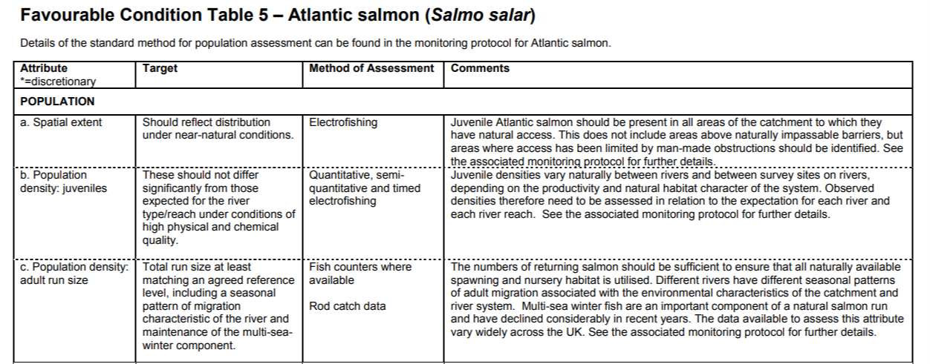
https://hub.jncc.gov.uk/assets/9b80b827-b44b-4965-be8e-ff3b6cb39c8e

Figure 1 River Wye salmon spawning compliance assessment 2020

Key to graphs
20th percentile trend line (in a 10 year period around 2 annual egg deposition values would be expected to fall below this line)
Annual egg deposition estimates
Conservation Limit
Upper and lower boundaries of the Bayesian Credible Interval.

Table 3 summary of salmon stock status on the Rivers Wye: provisional assessment results for 2020
Salmon stock status on the Rivers Wye
Current compliance status (2020) | At Risk
Predicted (+5yr) compliance status (2025) | Probably at Risk
Trend* | Declining (-)
Conservation Limit | 38.57 million eggs
Management Target | 48.69 million eggs
Egg deficit on MT** | 24.52 million eggs
Spawner deficit*** | 8,175

- Declining trend: Slight (-); Moderate(--); Steep (---)
** Egg deficit based on 5-year mean 2016-2020
** Spawner deficit expressed as 8lb fish equivalents; where average fecundity = 3,000 eggs per fish

White Clawed Crayfish (Atlantic Crayfish)
Native white clawed crayfish are a notified feature of the River Wye and an indicator of the health of the clay river feature in the River Lugg. Surveys were undertaken in 2013 by Hills ecology on Units 3-7 of the River Wye and Units 1-4 of the River Lugg.
The result of this survey indicate that the species is in ‘unfavourable’ condition for units 1-4 of the River Lugg, and either unfavourable or part destroyed for units 3-7 of the River Wye due to either the absence of white clawed crayfish, and/or the presence of non-native signal crayfish. Further investigation into habitat availability and historic survey data may be required to determine whether the status is unfavourable-declining, or part destroyed (https://www.therrc.co.uk/sites/default/files/files/Designated_Rivers/wyedrafttechnicalreport.pdf).

Water Quality Analysis – River Wye & Lugg
Water quality is not a notified feature of the SSSIs, it is one of the attributes assessed to indicate the health of the Rivers. Water quality targets are set out in the Monitoring Specifications for both the River Lugg SSSI and the River Wye SSSI.
Figure 2. River Wye & Lugg Ortho-P Current Compliance with Targets.
Figure 2 illustrates that for each monitoring location on the River Lugg, the Ortho-P target for the three-year mean target is currently being exceeded. The water quality data presented for the River Wye illustrates for each monitoring location that water quality is not currently exceeding the three year mean target.
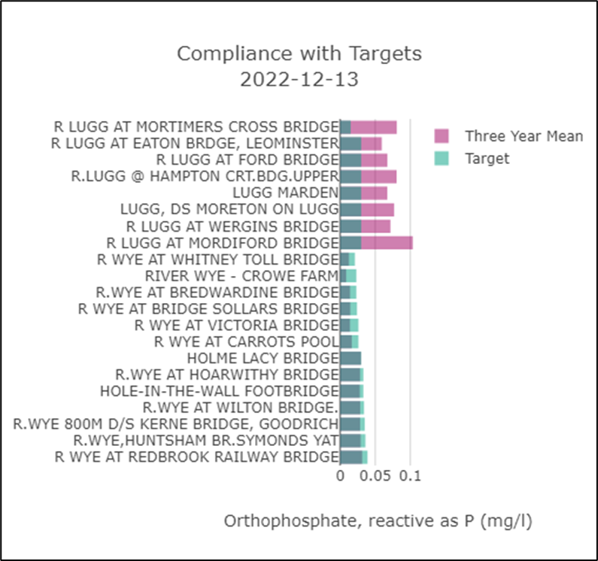
EA WFD Classification – Phosphate (up to 2019)
The water body - Lugg - conf Norton Bk to conf R Arrow – deteriorated from High to Moderate status for Phosphorus between the 2015 – 2019 classification.
The river Wye remain, increased or stayed at high or good throughout this period.
Table 4. EA Phosphate classification for the Wye & Lugg main river sections.
Catchment | Water Body | Physico-chemical element | 2015 | 2016 | 2019
River Lugg | Lugg - conf Norton Bk to conf R Arrow Water Body | Phosphate | High | Good | Moderate
River Lugg | Lugg - conf R Arrow to conf R Wye Water Body | Phosphate | Good | Good | Good
River Wye | Wye - Bredwardine Br to Hampton Bishop Water Body | Phosphate | High | Good | High
River Wye | Wye - Hampton Bishop to conf Kerne Br Water Body | Phosphate | High | High | Good
River Wye | Wye - conf Walford Bk to Bigsweir Br Water Body | Phosphate | Good | High | High

Water Quality Trends
The following graphs illustrate the trend in water quality over the past 20 years in the Wye and Lugg catchments. The monitoring locations are ordered upstream to downstream.
The red line is the site target for Ortho-P
The orange line plots a linear regression line with 95% Confidence Interval (CI)

River Lugg
Each of the plots for the monitoring locations along the River Lugg (u/s à d/s) show Ortho-P concentrations either increasing or stable over the past 20+ years – demonstrated by the positive or neutral linear regression lines.
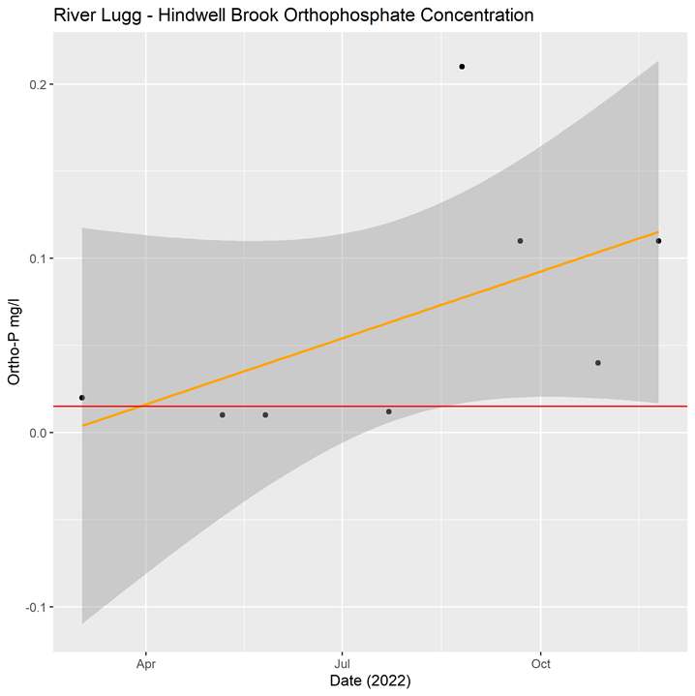
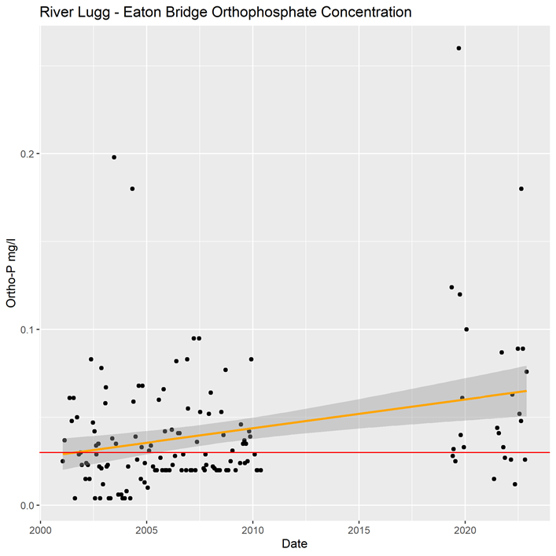
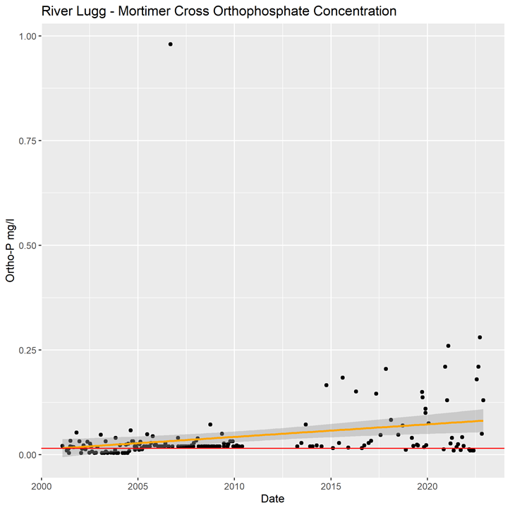
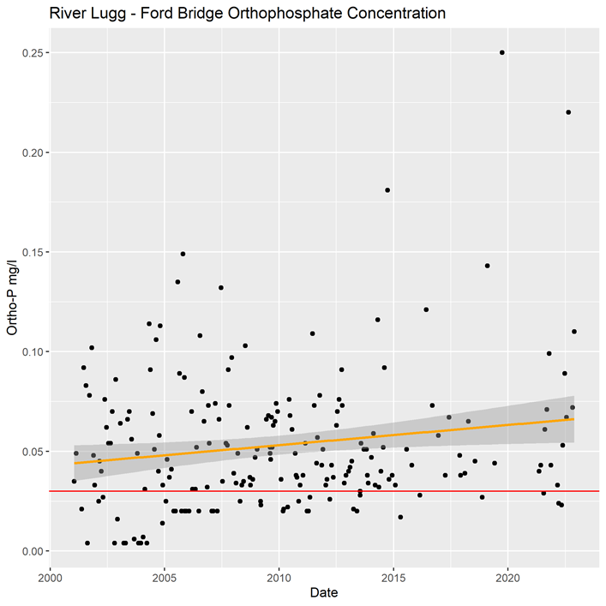
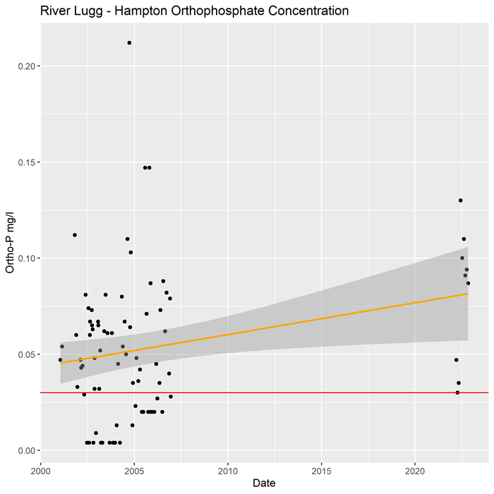
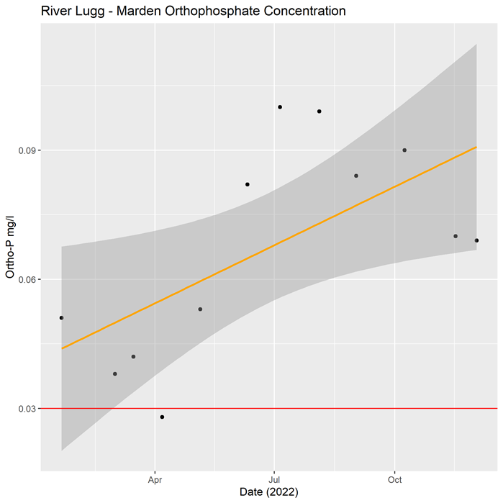
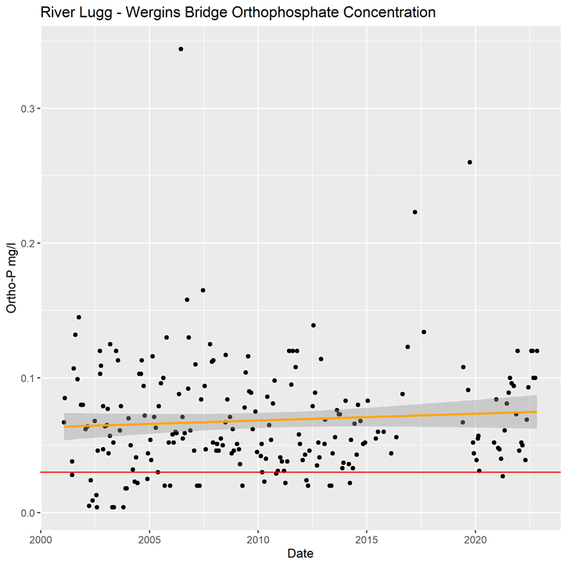
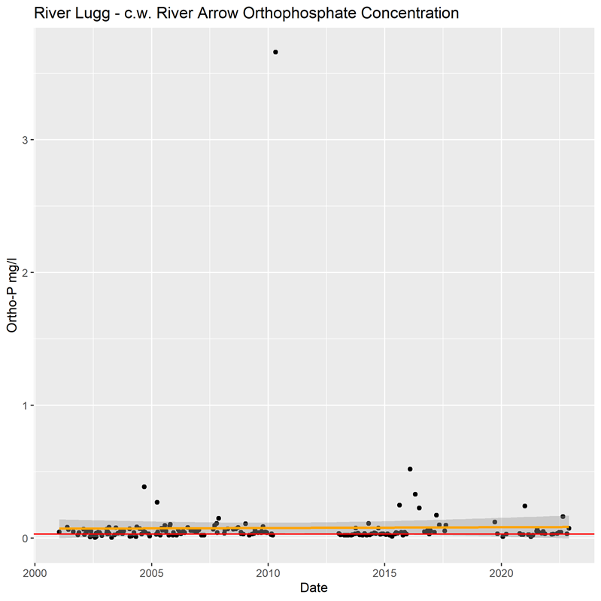
River Wye
Each of the plots for the monitoring locations along the River Wye (u/s à d/s) show Ortho-P concentrations generally either stable or slightly declining over the past 20+ years – demonstrated by the neutral or negative linear regression lines.
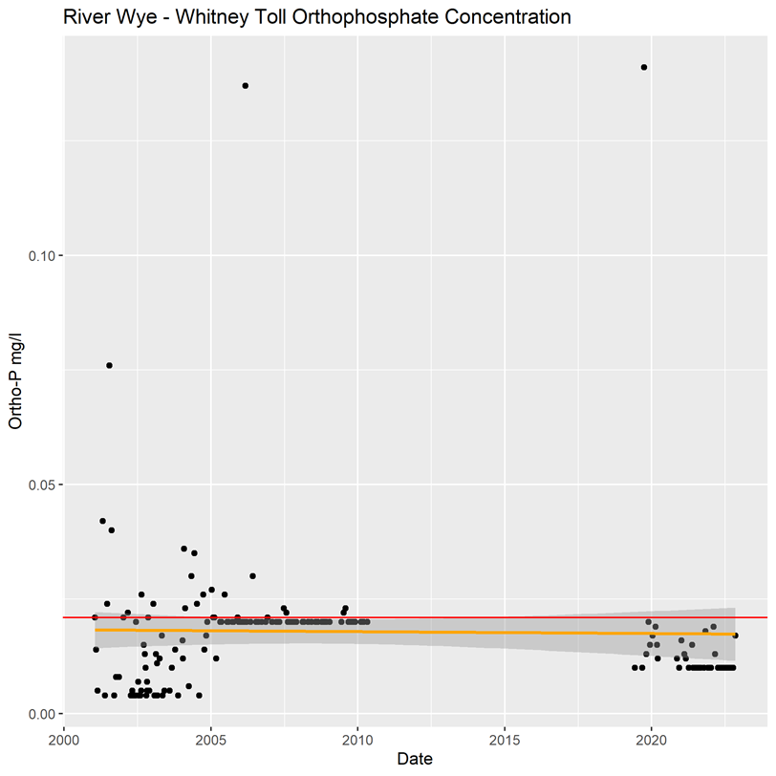
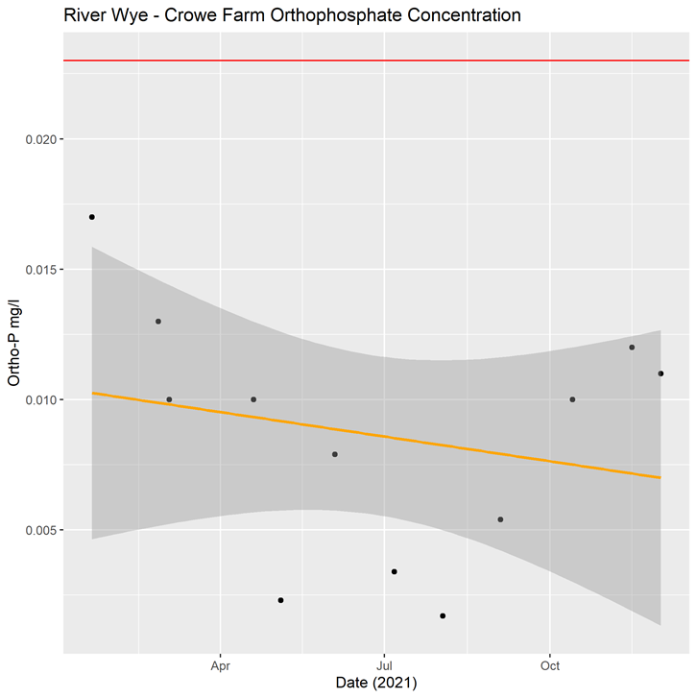
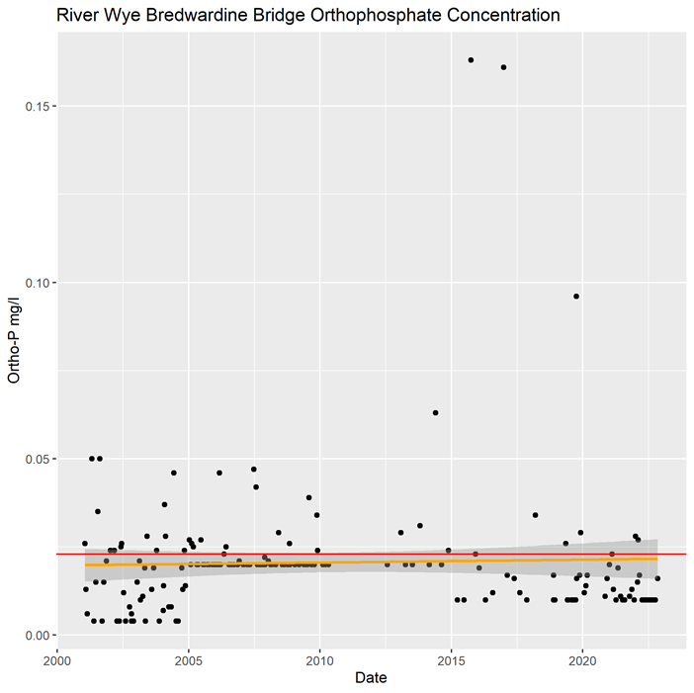
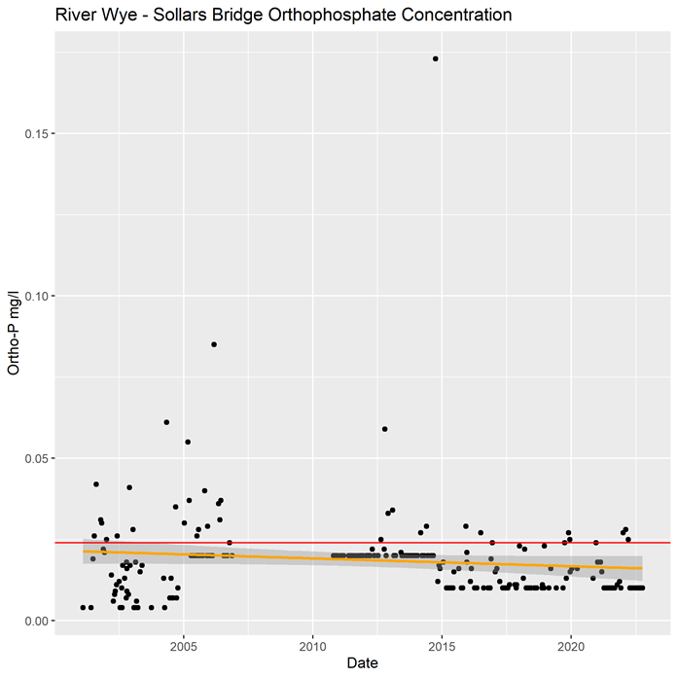
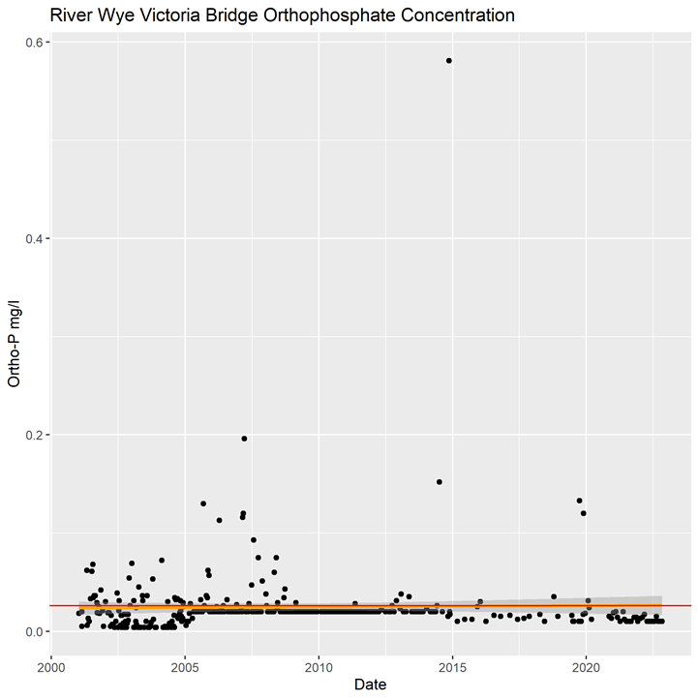
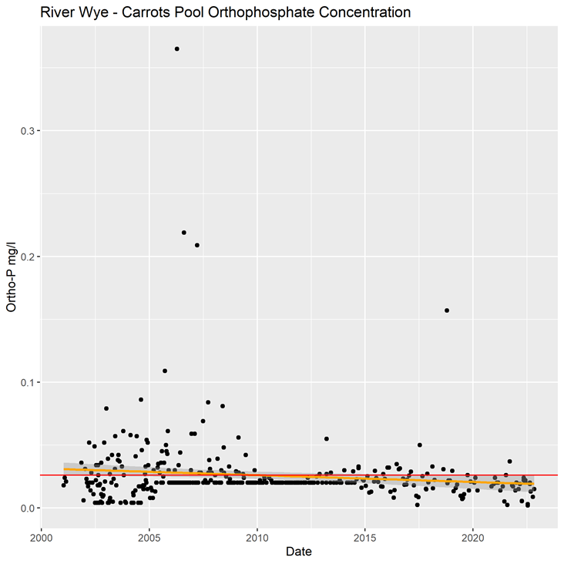

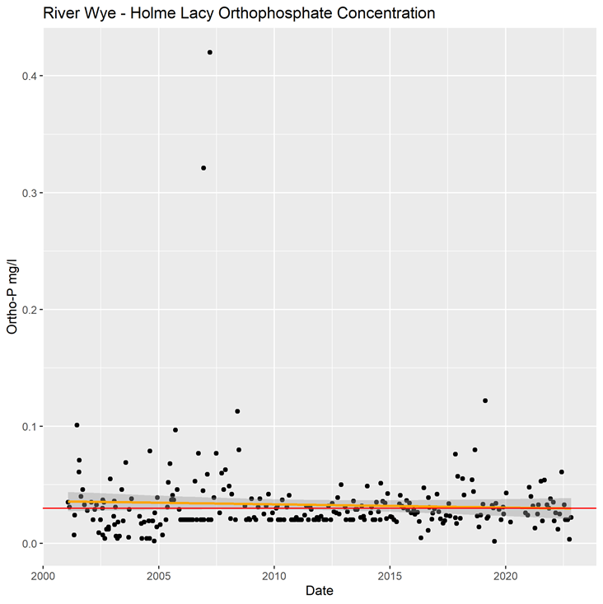
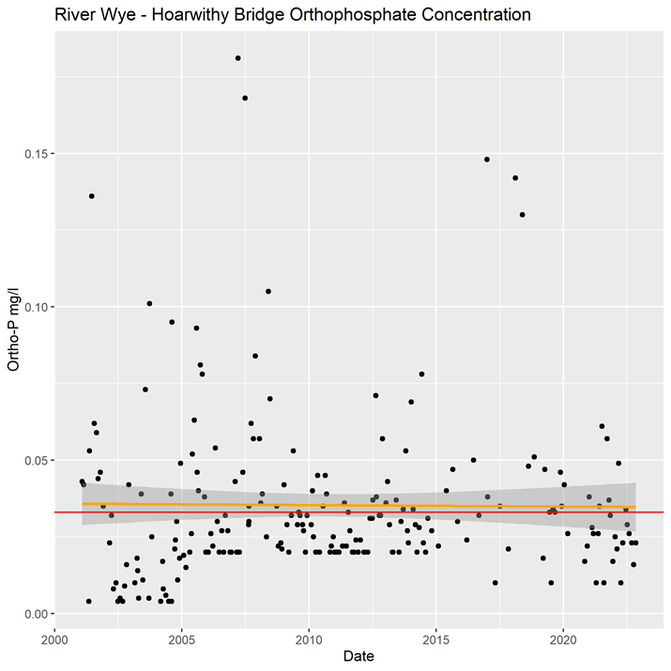
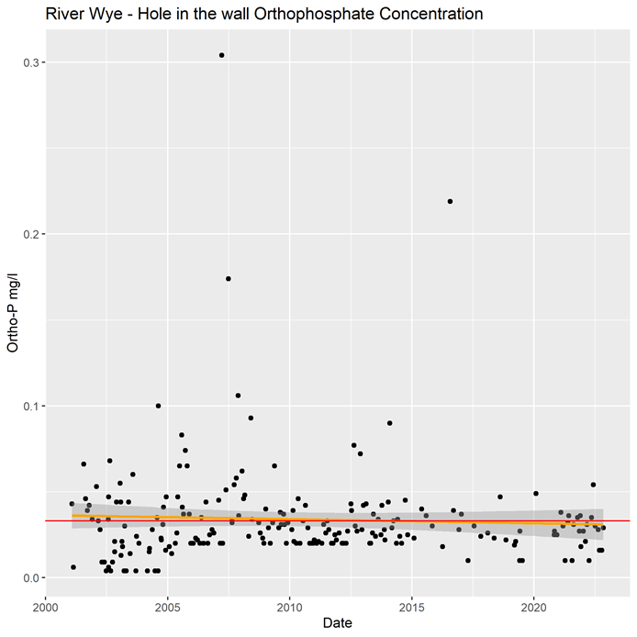
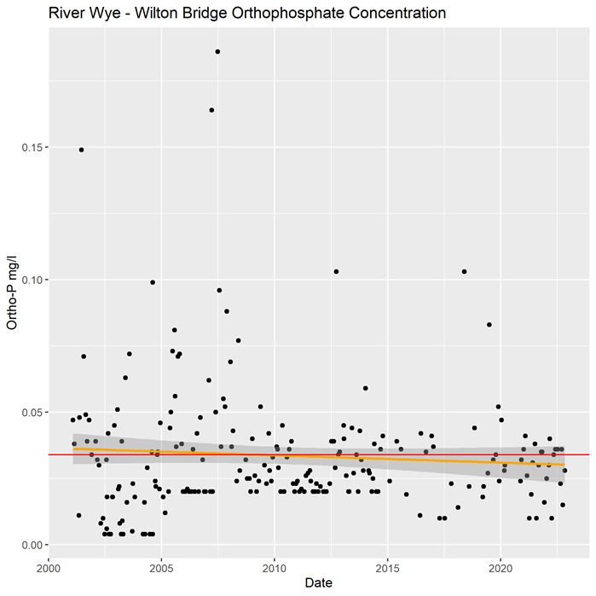
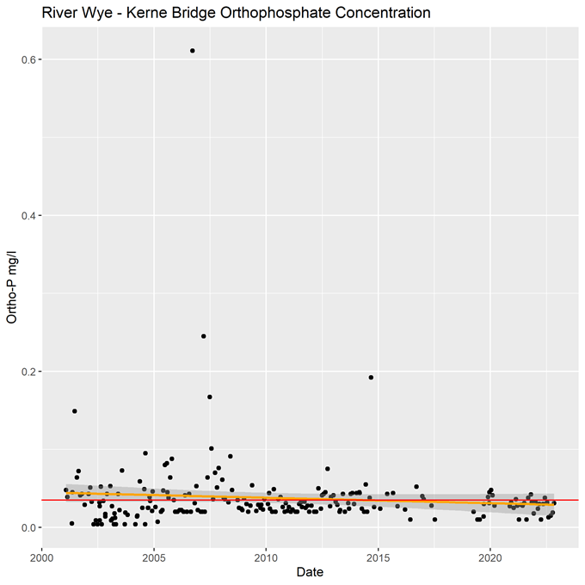
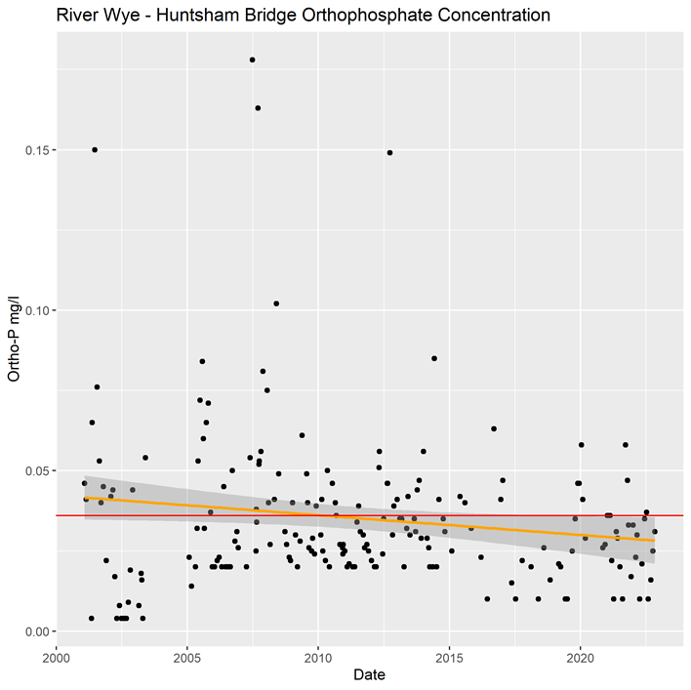
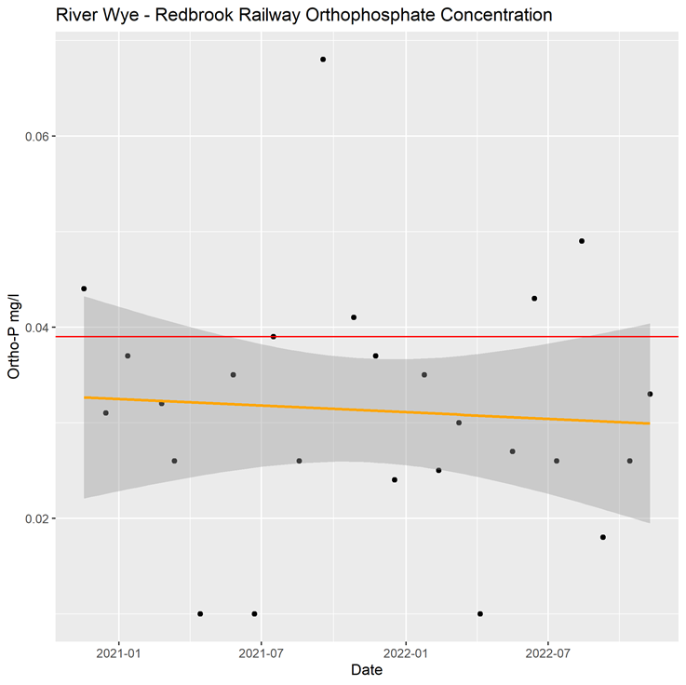

Consideration of changes to site condition.
There is evidence of failing condition on every unit of the River Wye and River Lugg (see table 4 and 5 below). Phosphate targets are exceeded on every unit of the river Lugg and the evidence shows phosphate levels to be increasing, demonstrating declining water quality. The River Wye is meeting its phosphate targets but is showing clear symptoms of eutrophication, despite stable phosphate levels, exacerbated by elevated water temperatures. This is supported by the moderate status of macrophytes & phytobenthos (this also encompasses algae trends).
White Clawed Crayfish have declined in both the Wye and Lugg.
The evidence from the assessment of Wye catchment salmon stocks (including the Lugg) suggests the number of Atlantic salmon returning to the catchment is in decline such that they are below the Conservation Limit and as a result Bylaws have been introduced.
Although there is much being done to try and address declines in both salmon and white clawed crayfish, there remains some uncertainty around the causes of the declines and therefore we cannot be assured that all necessary management is currently in place to deem the site to be recovering.
Regarding the decline in water quality on the Lugg, again despite significant efforts to address the issue by multiple stakeholders, given the continued declines we cannot be certain that the current measures in place will reverse this decline and further investigation is required.
Based on the evidence above, the site condition has been changed from Unfavourable Recovering to Unfavourable Declining based on CSMG as per the table below:

Table 5: Change in Condition for River Wye and River Lugg SSSIs monitoring units
Unit | SSSI | Reach | Condition prior to 30 May 2023 | Updated condition from May 2023
1 | River Wye | Tidal river - Estuary to Brockweir Bridge | Favourable | Unfavourable - Declining
2 | River Wye | Brockweir Bridge to Monmouth | Unfavourable - Recovering | Unfavourable - Declining
3 | River Wye | Monmouth to Ross | Unfavourable - Recovering | Unfavourable - Declining
4 | River Wye | Ross to Hereford | Unfavourable - Recovering | Unfavourable - Declining
5 | River Wye | Hereford to Bredwardine Bridge | Unfavourable - Recovering | Unfavourable - Declining
6 | River Wye | Bredwardine Bridge to Whitney Toll | Unfavourable - Recovering | Unfavourable - Declining
7 | River Wye | Whitney Toll to Hay | Unfavourable - Recovering | Unfavourable - Declining
1 | River Lugg | Bodenham Weir to Confluence with Wye | Unfavourable - Recovering | Unfavourable - Declining
2 | River Lugg | Bodenham Weir to Leominster | Unfavourable - Recovering | Unfavourable - Declining
3 | River Lugg | Leominster to Mortimers Cross | Unfavourable - Declining | Unfavourable - Declining
4 | River Lugg | Mortimers Cross to Presteigne | Unfavourable - Recovering | Unfavourable - Declining

Table 6. Summary of evidence and changes to condition by feature for the Wye SSSI
The following tables show a summary of the features assessed, condition and evidence used.
SSSI Notified Feature # | Monitored (Reportable) Feature | Designation (SSSI/SAC) | Unit No |  |  |  |  |  |  | Evidence
 |  |  | 1 | 2 | 3 | 4 | 5 | 6 | 7
Atlantic stream crayfish | S1092 White-clawed (or Atlantic stream) crayfish Austropotamobius pallipes | SSSI, SAC |  |  |  |  |  |  |  | Crayfish survey (2013).
Sea lamprey | S1095 Sea lamprey, Petromyzon marinus | SSSI, SAC | * | * | * | * | * | * | *
Brook lamprey | S1096 Brook lamprey, Lampetra planeri | SSSI, SAC | * | * | * | * | * | * | *
River lamprey | S1099 River lamprey, Lampetra fluviatilis | SSSI, SAC | * | * | * | * | * | * | *
Allis shad | S1102 Allis shad, Alosa alosa | SSSI, SAC | * | * | * | * | * | * | *
Twaite shad | S1103 Twaite shad, Alosa fallax | SSSI, SAC | * | * | * | * | * | * | *
Atlantic salmon | S1106 Atlantic salmon, Salmo salar | SSSI, SAC |  |  |  |  |  |  |  | Not achieving conservation limits, 2019 showed declining figures & overall declining trend.
Bullhead | S1163 Bullhead, Cottus gobio | SSSI, SAC |  | * |  | * | * | * | *
Common otter | S1355 Otter, Lutra lutra | SSSI, SAC |  | * | * | * | * | * | *
Invertebrates associated with riffles, river shingles and saltmarsh  Invertebrates associated with river deadwood  Invertebrates associated with bankside vegetation. | Invert. assemblage W111 shingle bank | SSSI | * | * | * | * | * | * | *
 | Invert. assemblage W114 stream & river margin | SSSI | * | * | * | * | * | * | *
 | Invert. assemblage W122 riparian sand | SSSI | * | * | * | * | * | * | *
Aquatic plant communities - rivers on sandstone, mudstone and hard limestone  Aquatic plant communities - clay rivers  Aquatic plant communities - lowland rivers with minimal gradient  Certain flowering plants and bryophytes  Beds of water crowfoot (Ranunculus spp.) | Rivers and Streams | SSSI | * |  |  |  |  |  |  | Evidence base used WFD macrophyte, phytobenthos & invertebrate classification data
 | H3260 Water courses of plain to montane levels with R. fluitantis | SAC |  |  | * | * | * | * | *

Table 7. Summary of evidence and changes to condition by feature for the Lugg SSSI

SSSI Notified Feature # | Monitored (Reportable) Feature | Designation (SSSI/SAC) | Unit No |  |  |  | Evidence
 |  |  | 1 | 2 | 3 | 4
Clay river displaying a transition from nutrient poor to naturally nutrient rich water chemistry  River plant communities | Rivers and streams | SSSI |  |  |  |  | Evidence base used EA water quality monitoring data (reactive phosphorus – WFD no deterioration – failure report) & WFD macrophyte reporting.
 | H3260 Water courses of plain to montane levels with Ranunculion fluitantis and Callitricho-Batrachion vegetation | SAC |  |  |  |  | Evidence base used EA water quality monitoring data (reactive phosphorus – WFD no deterioration – failure report). & WFD macrophyte reporting
Clay river displaying a transition from nutrient poor to naturally nutrient rich water chemistry | River Lamprey | SAC | *
 | Sea Lamprey | SAC | *
 | Brook Lamprey | SAC | * | * | * | *
 | Allis Shad | SAC | *
 | Twaite Shad | SAC | * | * | * | *
 | Atlantic Salmon | SAC |  |  |  |  | Not achieving conservation limits, 2019 showed declining figures & overall declining trend.
 | Bullhead | SAC | * | * | * | *
 | Invertebrate assemblage W1 flowing water | SAC | * | * | * | *
 | White Clawed Crayfish | SAC |  |  |  |  | Crayfish survey (2013).
Common otter | Otter | SSSI/SAC | * | * | * | *

# List of notified features as confirmed by Natural England’s Citation Review project in May 2023. This project establishes a robust and consistent approach to interpreting the notified features described on every SSSI Citation. Work is ongoing to update Monitoring Specifications (formerly SSSI Favourable Condition Tables) and the information on Designated Site Viewer to reflect the refined list of notified features and how these relate to what is monitored ‘in the field’ (monitored (reportable) features). These changes do not impact the evidence and conclusions reached in November 2022 and captured in this document.
* Not assessed

Xxxx = Declining condition

When undertaking a condition assessment, the unit status should reflect the status of the feature with the lowest condition score.
Vicki Howden - West Midlands Senior Freshwater advisor (June 2022)
Daisy Burris - West Midlands Freshwater Adviser (November 2022)
Claire Minett – Operations Manager (November 2022)
Jonathan Blowers – Operations Manager (updated May 2023) to reflect Natural England’s revised approach to interpreting and naming notified features resulting from an ongoing review of SSSI Citations.

Source NRW Technical Case 2021

